**727721EUIT158-SRIKANTH S**

**CLASS EXCERCISE _4**

**TASK_1:**

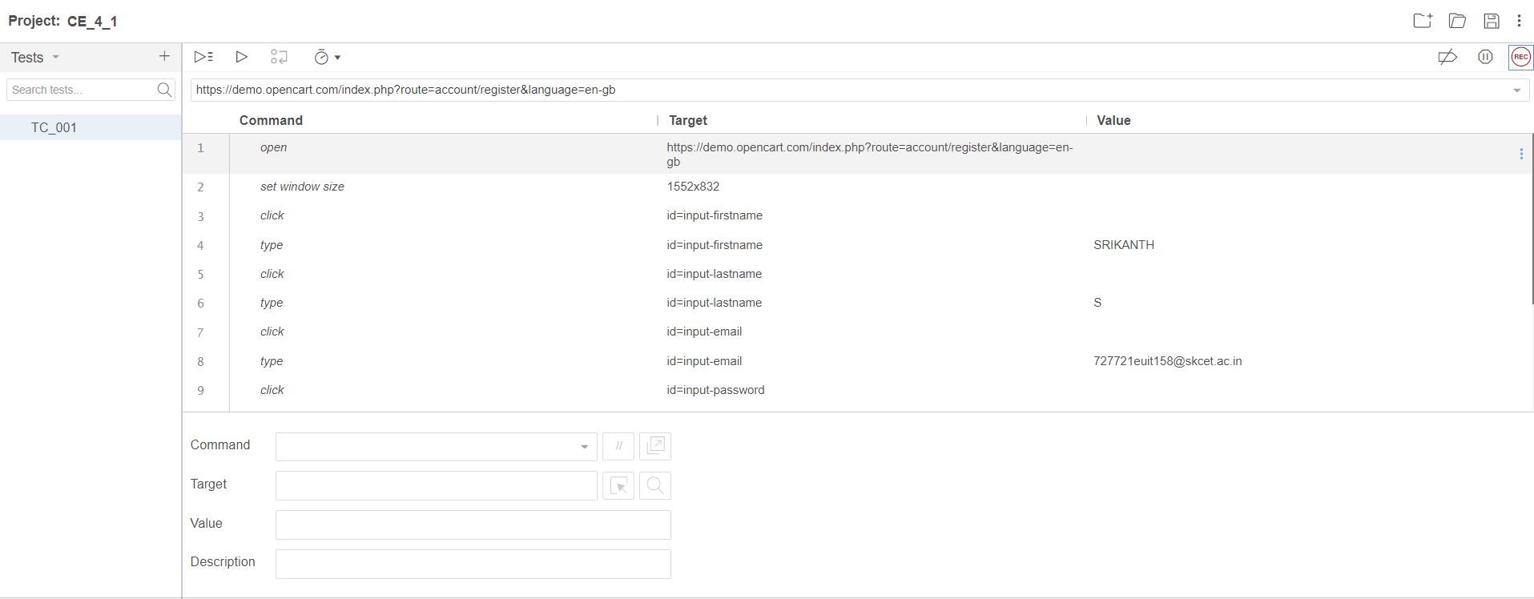

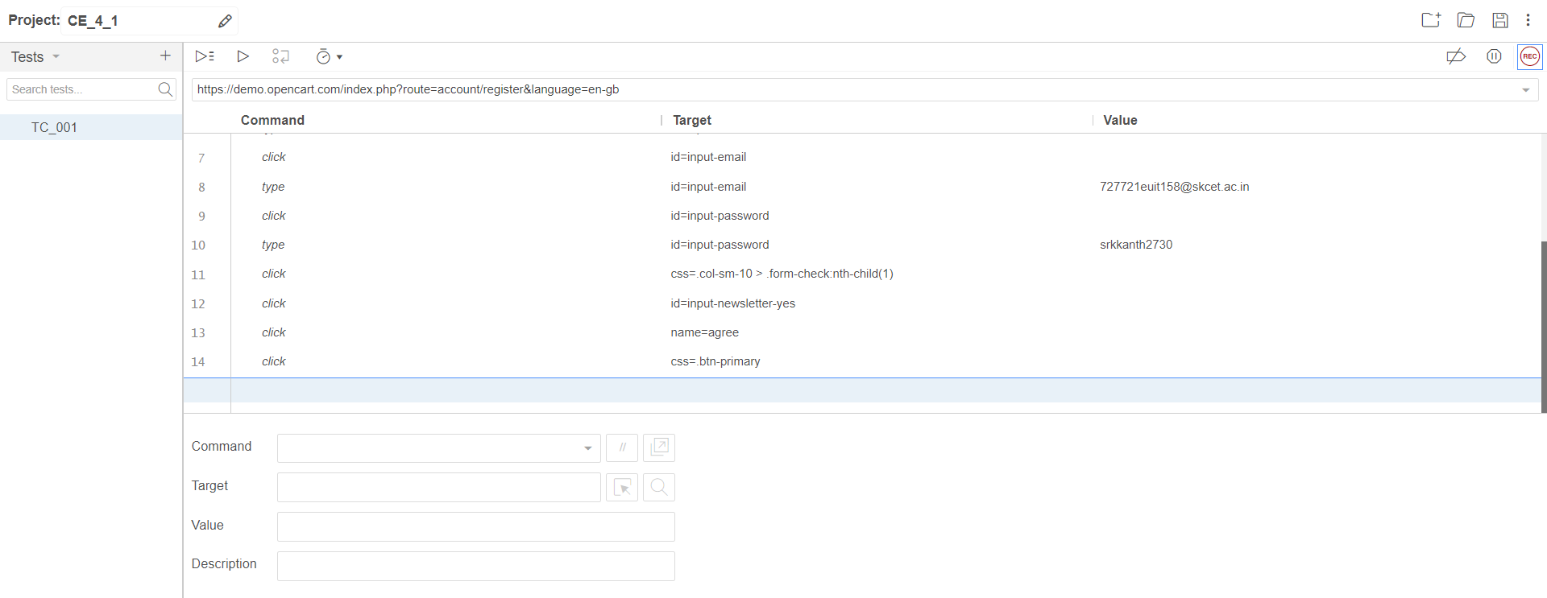

**TASK_2:**

package com.demo.test;

import org.openqa.selenium.By;

import org.openqa.selenium.JavascriptExecutor;

import org.openqa.selenium.WebDriver;

import org.openqa.selenium.WebElement;

import org.openqa.selenium.chrome.ChromeDriver;

import org.openqa.selenium.chrome.ChromeOptions;

import io.github.bonigarcia.wdm.WebDriverManager;

public class CE_3_2

{

public static void main( String[] args ) throws InterruptedException

{

ChromeOptions co=new ChromeOptions();

co.addArguments ("--remote-allow-origins=*");

WebDriverManager.chromedriver().setup ();

WebDriver driver=new ChromeDriver();

driver.get("https://demo.opencart.com/index.php?route=account/register&language=en-gb");

driver.manage().window().maximize();

WebElement fname=driver.findElement(By.id("input-firstname"));

fname.sendKeys("Srikanth");

WebElement lname=driver.findElement(By.id("input-lastname"));

lname.sendKeys("s");

WebElement email=driver.findElement(By.cssSelector("input#input-email"));

email.sendKeys("727721euit174@skcet.ac.in");

JavascriptExecutor js= (JavascriptExecutor) driver;

js.executeScript("window.scrollBy (0,1000)", "");

Thread.sleep(2000);

driver.findElement(By.id("input-password")).sendKeys("srikanth123");

Thread.sleep(2000);

driver.findElement(By.id("input-newsletter-yes")).click();

Thread.sleep(2000);

driver.findElement(By.name("agree")).click();

Thread.sleep(2000);

driver.findElement(By.xpath("//*[@id=\"form-register\"]/div/div/button")).click();

}

}

**TASK_3:**

package com.demo.test;

import org.openqa.selenium.By;

import org.openqa.selenium.JavascriptExecutor;

import org.openqa.selenium.WebDriver;

import org.openqa.selenium.chrome.ChromeDriver;

import org.openqa.selenium.chrome.ChromeOptions;

import io.github.bonigarcia.wdm.WebDriverManager;

public class CE_3

{

public static void main(String[] args ) throws InterruptedException

{

ChromeOptions co=new ChromeOptions();

co.addArguments ("--remote-allow-origins=*");

WebDriverManager.chromedriver().setup ();

WebDriver driver=new ChromeDriver();

driver.get ("https://demo.opencart.com/index.php?route=checkout/voucher&language=en-gb");

driver.manage().window().maximize();

driver.findElement(By.xpath("//input[@id=\"input-to-name\"]")).sendKeys ("SRIKANTH");

JavascriptExecutor js= (JavascriptExecutor)driver;

js.executeScript("window.scrollBy (0,500)","");

Thread.sleep(5000);

driver.findElement(By.xpath("//input[@id=\"input-theme-6\"]")).click();

}

}

**TASK_4:**

package com.demo.test;

import org.openqa.selenium.By;

import org.openqa.selenium.JavascriptExecutor;

import org.openqa.selenium.WebDriver;

import org.openqa.selenium.chrome.ChromeDriver;

import org.openqa.selenium.chrome.ChromeOptions;

import io.github.bonigarcia.wdm.WebDriverManager;

public class CE_4_4

{

public static void main(String[] args ) throws InterruptedException

{

ChromeOptions co=new ChromeOptions();

co.addArguments ("--remote-allow-origins=*");

WebDriverManager.chromedriver().setup ();

WebDriver driver=new ChromeDriver();

driver.get ("https://j2store.net/free/");

driver.manage().window().maximize() ;

driver.findElement(By.xpath("/html/body/div[2]/div/div[2]/div/div/div/div/ul/li[1]/a/img")).click();

driver.navigate().back();

driver.navigate().forward();

driver.navigate().refresh();

driver.close();

// Thread.sleep(5000);

}

}

**TASK_5.1:**

package com.demo.test;

import org.openqa.selenium.By;

import org.openqa.selenium.JavascriptExecutor;

import org.openqa.selenium.WebDriver;

import org.openqa.selenium.chrome.ChromeDriver;

import org.openqa.selenium.chrome.ChromeOptions;

import io.github.bonigarcia.wdm.WebDriverManager;

public class CE_4_5{

public static void main(String[] args)throws InterruptedException {

ChromeOptions co=new ChromeOptions();

co.addArguments("--remote-allow-origins=*");

WebDriverManager.chromedriver().setup();

WebDriver d=new ChromeDriver(co);

d.get("https://j2store.net/free/");

d.manage().window().maximize();

String CurrentUrl=d.getCurrentUrl();

String ExpectedUrl="https://j2store.net/free/";

if(CurrentUrl.equals(ExpectedUrl))

{

System.out.println("URL MATCHED.");

}

else

{

System.out.println("URL NOT MATCHED.");

}

d.findElement(By.xpath("//*[@id=\"Mod112\"]/div/div/ul/li[1]/a")).click();

String CUrl=d.getCurrentUrl();

String EUrl="https://j2store.net/free/index.php/shop?filter_catid=11";

if(CUrl.equals(EUrl))

{

System.out.println("URL MATCHED.");

}

else

{

System.out.println("URL NOT MATCHED.");

}

}

}

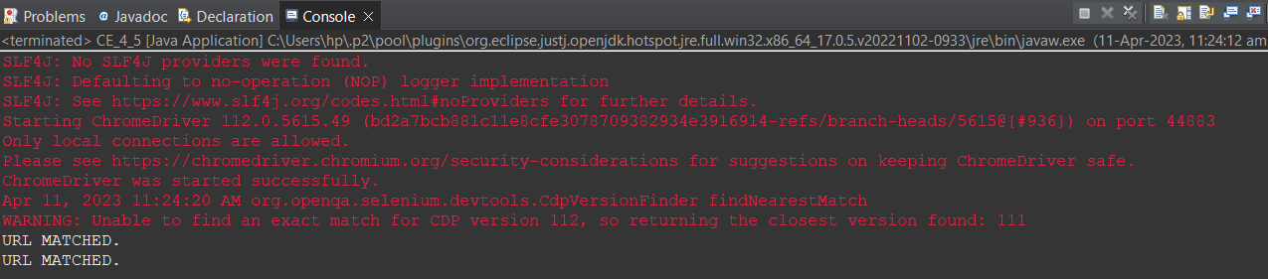

**TASK_5.2:**

package com.demo.test;

import org.openqa.selenium.By;

import org.openqa.selenium.WebDriver;

import org.openqa.selenium.WebElement;

import org.openqa.selenium.chrome.ChromeDriver;

import org.openqa.selenium.chrome.ChromeOptions;

import java.util.*;

import io.github.bonigarcia.wdm.WebDriverManager;

public class CE_4_52{

public static void main(String []Args) {

ChromeOptions co=new ChromeOptions();

co.addArguments("--remote-allow-origins=*");

WebDriverManager.chromedriver().setup();

WebDriver driver =new ChromeDriver(co);

driver.get("https://j2store.net/free/");

WebElement el6= driver.findElement(By.linkText("Clothing (5)"));

el6.click();

List<WebElement> li=driver.findElements(By.xpath("//h2[@itemprop=\"name\"]"));

for(WebElement e:li) {

System.out.println(e.getText());

}

}

}

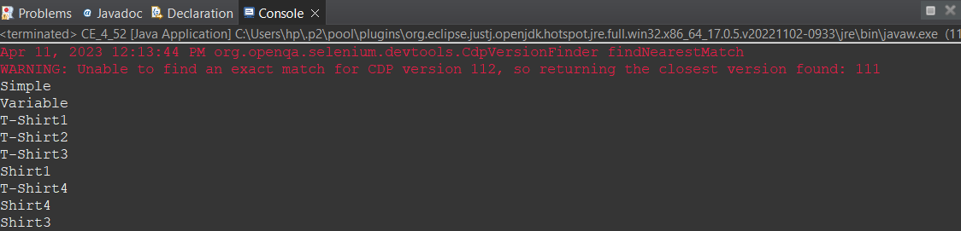

**CLASS_EXCERSIE_5:**

**TASK_1:**

package com.demo.test;

import java.awt.Desktop.Action;

import java.util.List;

import org.openqa.selenium.By;

import org.openqa.selenium.WebDriver;

import org.openqa.selenium.WebElement;

import org.openqa.selenium.chrome.ChromeDriver;

import org.openqa.selenium.chrome.ChromeOptions;

import org.openqa.selenium.interactions.Actions;

import io.github.bonigarcia.wdm.WebDriverManager;

public class CE_5_1 {

public static void main( String[] args )throws InterruptedException{

ChromeOptions co=new ChromeOptions();

co.addArguments("--remote-allow-origins=*");

WebDriverManager.chromedriver().setup();

WebDriver d=new ChromeDriver(co);

d.get("https://demoqa.com/droppable/");

d.manage().window().maximize();

WebElement fromElement =d.findElement(By.xpath("//*[@id=\"draggable\"]") );

WebElement toElement = d.findElement(By.xpath("//*[@id=\"droppable\"]"));

Actions act=new Actions(d);

act.dragAndDropBy(fromElement,270, 70).build().perform();

d.close();

}

}

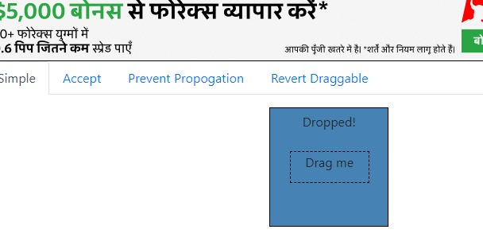

**TASK 2:**

package com.demo.test;

import org.openqa.selenium.By;

import org.openqa.selenium.WebDriver;

import org.openqa.selenium.WebElement;

import org.openqa.selenium.chrome.ChromeDriver;

import org.openqa.selenium.chrome.ChromeOptions;

import org.openqa.selenium.interactions.Actions;

import io.github.bonigarcia.wdm.WebDriverManager;

public class CE_5_2 {

public static void main(String[] args) {

WebDriverManager.chromedriver().setup();

ChromeOptions co=new ChromeOptions();

co.addArguments ("--remote-allow-origins=*");

WebDriver driver=new ChromeDriver (co);

driver.get("https://jqueryui.com/droppable/");

driver.manage().window().maximize();

driver.switchTo().frame (0);

WebElement drag=driver.findElement(By.id("draggable"));

WebElement drop=driver.findElement(By.id("droppable"));

Actions a=new Actions (driver);

a.dragAndDrop (drag, drop).build() .perform();

}

}

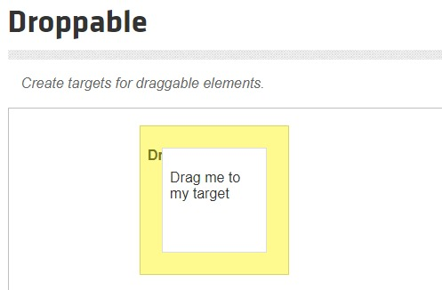

**TASK_3:**

package com.test.Day_5;

import org.openqa.selenium.Alert;

import org.openqa.selenium.By;

import org.openqa.selenium.WebDriver;

import org.openqa.selenium.WebElement;

import org.openqa.selenium.chrome.ChromeDriver;

import org.openqa.selenium.chrome.ChromeOptions;

import org.openqa.selenium.interactions.Actions;

import io.github.bonigarcia.wdm.WebDriverManager;

public class ClassExcercise3 {

public static void main(String[] args)throws InterruptedException {

WebDriverManager.chromedriver().setup();

ChromeOptions co=new ChromeOptions();

co.addArguments ("--remote-allow-origins=*");

WebDriver d=new ChromeDriver (co);

d.get("https://demo.guru99.com/test/delete_customer.php");

d.manage().window().maximize();

d.findElement(By.xpath("/html/body/form/table/tbody/tr[2]/td[2]/input")).sendKeys("401");

Thread.sleep(1000);

d.findElement(By.xpath("/html/body/form/table/tbody/tr[3]/td[2]/input[1]")).click();

Alert alert1=d.switchTo().alert();

Thread.sleep(3000);

alert1.dismiss();

d.findElement(By.xpath("/html/body/form/table/tbody/tr[3]/td[2]/input[2]")).click();

d.findElement(By.xpath("/html/body/form/table/tbody/tr[2]/td[2]/input")).sendKeys("402");

Thread.sleep(1000);

d.findElement(By.xpath("/html/body/form/table/tbody/tr[3]/td[2]/input[1]")).click();

Alert alert2=d.switchTo().alert();

Thread.sleep(3000);

alert1.accept();

Alert alert3=d.switchTo().alert();

String txt=alert3.getText();

alert3.accept();

System.out.println(txt);

}

}

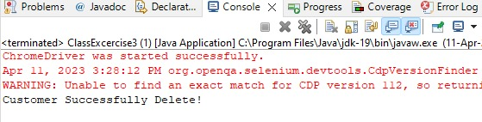

**TASK_4:**

package com.test.Day_5;

import org.openqa.selenium.Alert;

import org.openqa.selenium.By;

import org.openqa.selenium.WebDriver;

import org.openqa.selenium.chrome.ChromeDriver;

import org.openqa.selenium.chrome.ChromeOptions;

import io.github.bonigarcia.wdm.WebDriverManager;

public class ClassExcercise4 {

public static void main(String[] args)throws InterruptedException {

WebDriverManager.chromedriver().setup();

ChromeOptions co=new ChromeOptions();

co.addArguments ("--remote-allow-origins=*");

WebDriver d=new ChromeDriver (co);

d.get("https://www.abhibus.com/bus-ticket-booking");

d.manage().window().maximize();

d.findElement(By.xpath("//*[@id=\"source\"]")).sendKeys("Coimbatore");

d.findElement(By.xpath("//*[@id=\"destination\"]")).sendKeys("Chennai");

Thread.sleep(5000);

d.findElement(By.xpath("//*[@id=\"datepicker1\"]")).click();

d.findElement(By.xpath("//*[@id=\"ui-datepicker-div\"]/div[2]/table/tbody/tr[4]/td[1]/a")).click();

}

}

**TASK_5:**

package com.test.ClassExercise;

import org.openqa.selenium.By;

import org.openqa.selenium.Keys;

import org.openqa.selenium.WebDriver;

import org.openqa.selenium.WindowType;

import org.openqa.selenium.chrome.ChromeDriver;

import org.openqa.selenium.chrome.ChromeOptions;

import io.github.bonigarcia.wdm.WebDriverManager;

public class D5_CE5 {

public static void main(String[] args) throws InterruptedException {

WebDriverManager.chromedriver().setup();

ChromeOptions co=new ChromeOptions();

co.addArguments("--remote-allow-origins=*");

WebDriver driver=new ChromeDriver(co);

driver.get("https://www.google.com/");

driver.manage().window().maximize();

driver.findElement(By.name("q")).sendKeys("Apple");

driver.findElement(By.name("q")).sendKeys(Keys.ENTER);

System.out.println(driver.getWindowHandle());

System.out.println(driver.getTitle());

driver.switchTo().newWindow(WindowType.TAB);

driver.get("https://www.google.com/");

driver.manage().window().maximize();

driver.findElement(By.name("q")).sendKeys("Selenium");

driver.findElement(By.name("q")).sendKeys(Keys.ENTER);

System.out.println("/n"+driver.getWindowHandle());

System.out.println("\n"+driver.getTitle());

driver.switchTo().newWindow(WindowType.TAB);

driver.get("https://www.google.com/");

driver.manage().window().maximize();

driver.findElement(By.name("q")).sendKeys("Cucumber");

driver.findElement(By.name("q")).sendKeys(Keys.ENTER);

System.out.println("/n"+driver.getWindowHandle());

System.out.println("\n"+driver.getTitle());

}

}

